**UGANDA CERTIFICATE OF LOWER SECONDARY EDUCATION**

**END OF TERM II ASSESSMENT 2023**

**S.3 MATHEMATICS**

**TIME: 2 Hours**

**INSTRUCTIONS:**

Attempt **all** questions from section **A** and any **three** questions from section **B**.

# SECTION A: Attempt all questions (40 Marks)

1. a) Find the HCF and LCM of 84, 1386 and 210. (02 marks)

b) Express 4312 in terms of its prime factors. (02 marks)

1. Draw an arrow diagram to show that the relation “is a factor of” given sets

A = {2,3,4,5,6,7} and B = {10,12,14,15,18} (04 marks)

1. You are provided with cards each having digits 2, 3, 5, 7, 6, 15, 18, 20, 35.

a) Arrange them by forming two sets so that each digit is associated with its prime factor. (02 marks)

b) Identify the members in the object set and the image set. (02 marks)

1. A rectangle ABCD has vertices A(2, 2), B(5, 2), C(5, -4) and D(2, -4). It is translated by the vector along 2 and down by 3. By graphical approach find the images of A, B, C and D. (04 marks)
2. Study the table and derive the relationship and fill the table. (04 marks)

|  |  |  |  |
| --- | --- | --- | --- |
|  | Plus 12 | |  |
| 34 | 58 | _ | _ |
| _ | _ | 37 | 12 |

1. Identify the domain and range from the ordered pairs (2,6), (-3,7), (5,0),(-1,-5), and (4,7). (04 marks)
2. By using a diagram, show the direction of vector (04 marks)

=

−

4

3

1. Tabulate the values from the given relation 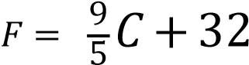 for the values of C ranging from 0°C to 100°C using the interval of 100C. (04marks)
2. A flower garden in the form of a square has an area of X2-6x + 9.
3. Work out the length of the side.
4. If the flower garden has an area of 100 square metres, workout the value of x. (04marks)

1. Figure A and B are similar. If the radius of A= 8 cm and the linear scale factor between A and B is 4.

A B

8

cm

Find the;

|  |  |
| --- | --- |
| (a). | Radius of B |
| (b). | Area scale factor |
| (c). | Volume scale factor (04marks) |

# SECTION B: Attempt any three questions (45 marks)

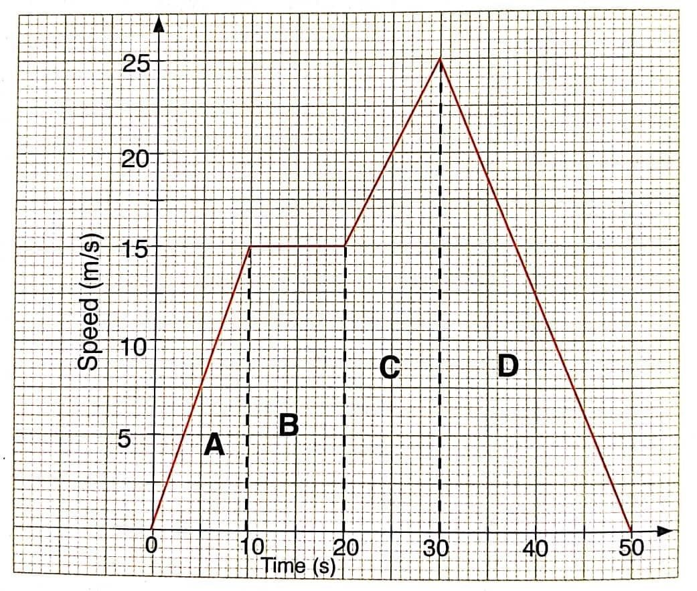10. Study the graph below and use it to answer the following questions.

1. What is the speed of the object between 10 and 20 seconds in the graph?
2. Explain the movements of the object at A and C.
3. In which section is the object travelling fastest?
4. In which section has the object stopped travelling?
5. What is the distance covered from the starting point to the destination?
6. Explain what the gradients of A, C and D mean. (15 marks)
7. Triangle ABC with vertices A(1, 3), B(3, 3), C(3, 1) is enlarged with a scale factor of -4 about (2,2) to triangle A’B’C’. Triangle A’B’C’ is then translated by a vector T(-1,2) to triangle A’’B’’C’’.
8. Draw on the same axes the triangles ABC, A’B’C’ and A’’B’’C’’.
9. Write down the coordinates of the two image triangles. (15 marks)
10. A rectangle of length (4x- 1) cm and width 2x cm has an area of 10 cm2. Determine the maximum value of the length and width of the rectangle, hence find the perimeter. (15 marks)

**END**